Project Report
The main purpose of this real life project is to help people in tracking their expenses in a very easy and smart way.I have implemented all the concepts and programming skills I have learnt in python so far.The most interesting thing of the entire program is that it tracks all the expenses of a person in a very easy,smart and in a detailed way.It saves a lot of time and energy of a person who is trying to track his/her expenses manually.
The outputs attached below will help to analyze the work flow of this program:
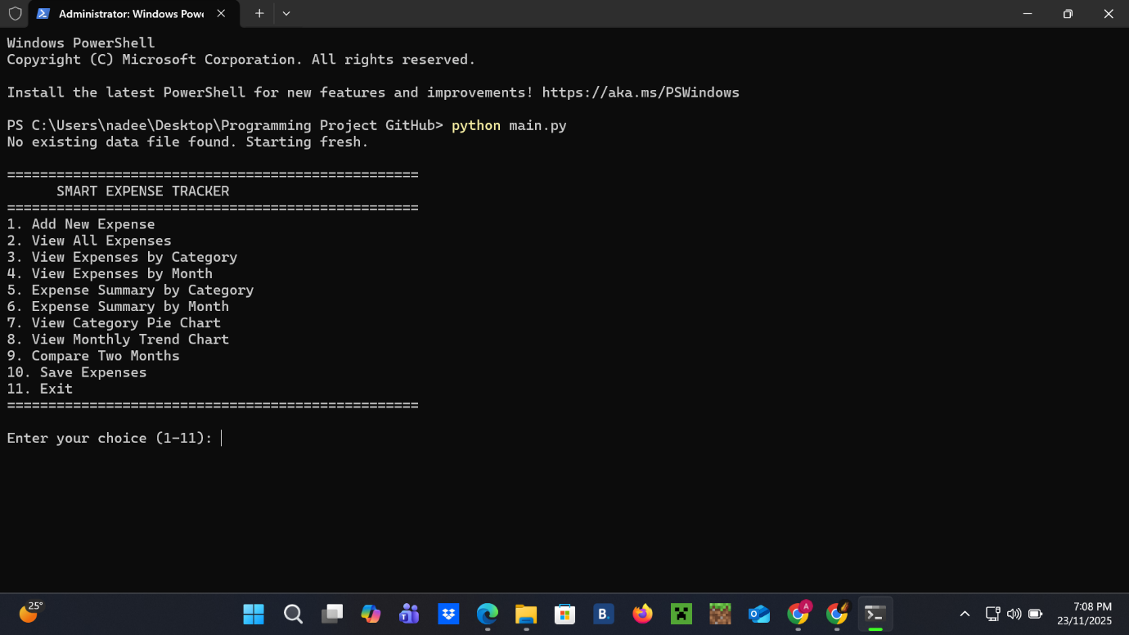
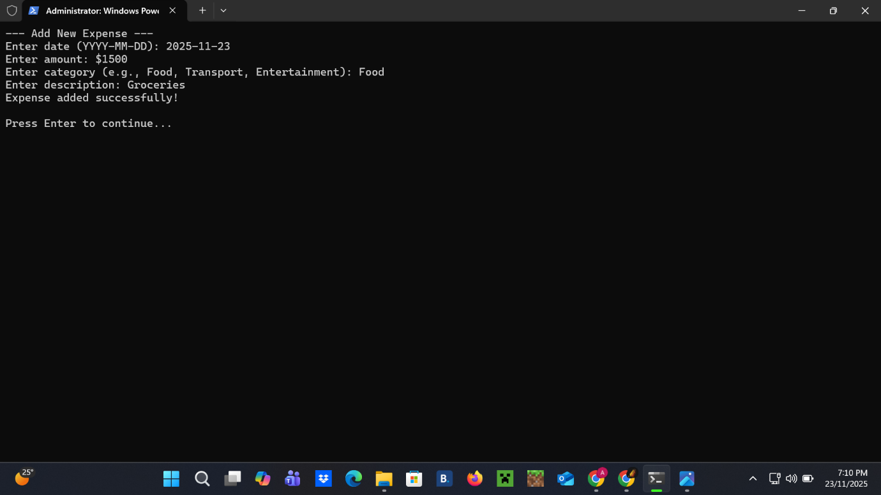
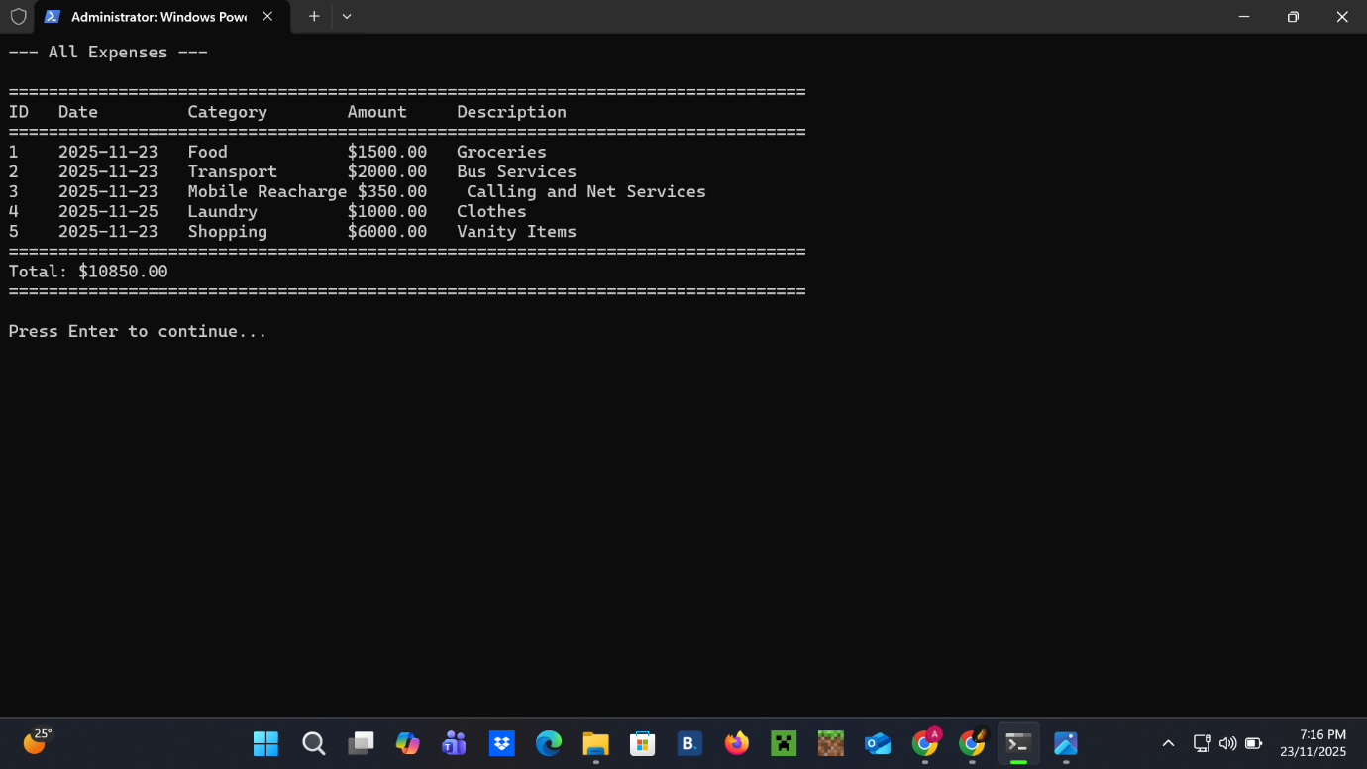
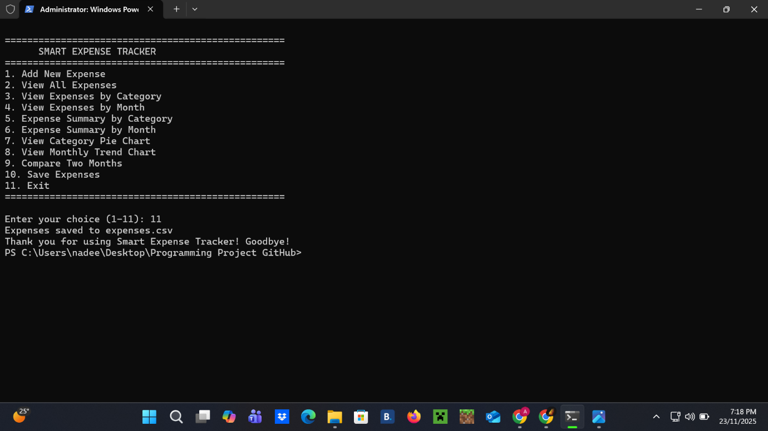
For better analysis and understanding the expenses can be represented in the form of pie chart and trend chart.
I have used some library functions,concept of conditional statements,data structure,jump statements,use of creating functions and calling them in main method and other related topics.
At first,it will show a menu where there are many options like to add new expense,to view all expenses,to view expenses by category wise or by month,etc.
Secondly the user have to give his choice as per his/her requirement.
The user can add his/her expenses and can view it by category wise as well as monthly.It will give a proper outlook of all the expenses.
The user can compare the expenses and track them by using pie chart and trend chart.
At end,it will save all the expenses and give a concluding statement to the user.
It was a very nice experience to work on this project because I got an opportunity to learn new things and enhance my programing skills.I think this project will be beneficial for all the people.

